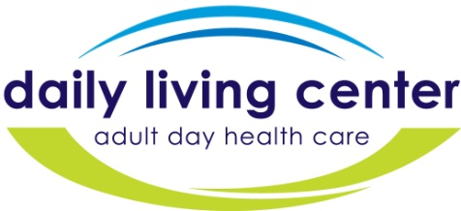

2014 GOLDEN MILE ADDITIONAL DETAILS

REGISTRATION 1:00—1:45 PM
Pavilion at Constitution Park, Waynesboro
Turn in your pledge sheets and collections. (Checks are to be made out to the Daily Living Center and remember pledges are tax deductible). Please have your cash and checks sealed in an envelope with your name on the envelope. Sign the waiver form.

RUN/WALK RACE BEGINS AT 2:00 PM
It is approximately one mile long and starts at the Pavilion of Constitution Park by the river in Waynesboro and ends at the YMCA.

AWARD CEREMONY 2:45 PM
St. John’s Episcopal Church Fellowship Hall
Corner of Wayne Avenue and 13th Street
REFRESHMENTS
All race participants are invited to participate.

THE GRAND PRIZE
Awarded to the TOP Fundraiser.

PRIZES
Prizes will be awarded to 1st, 2nd and 3rd male and female runners and walkers. Every competitor will be eligible for door prizes.

LET’S HAVE FUN FOR A GREAT CAUSE!

For more information please call the Daily Living Center 540-949-4151.

